RECRUITMENT GUIDANCE

Developing Recruitment Materials & Methods
All methods and materials for recruiting participants for a research study (including the final copy of printed advertisements, scripts, audio or video tapes, or web sites, etc.) must be reviewed and approved by the IRB prior to use. The proposed recruitment methods and materials can be submitted with the New Project application for IRB review or submitted later as an amendment to the IRB approved research.
Recruitment letters, posters and brochures reviewed by the IRB must contain all information, text, and graphic design elements of the final draft. IRB approval is required prior to implementation of any substantial changes in the content of recruitment materials such as research activities, inclusion criteria, compensation, etc.

Required Elements for Recruitment Materials
- CSULB name and department or college
- Study title
- Information that recruitment is for a research study. A sentence or two describing the study purpose.
- A brief description of what is expected of participants.
- Time commitment for participation and the location or if participation is online.
- Eligibility criteria. Especially if compensation depends on meeting these criteria. For example, “athletes only”, “CSULB students only,” etc.
- Ineligibility criteria listed if appropriate.
- State whether participants will be compensated. (e.g., You will be compensated for your participation, you will receive a gift card to X for $ or class credit for your participation.
- The amount of payment may be included but should not be the most prominent element.
- The PI’s name (or other study contact name) with either a phone number or e-mail address.

Flyers/Letters
The flyer or letter should feature the study title, study’s purpose, eligibility criteria, research activities, time commitment, compensation, and method of signing up. It is crucial that these materials are clear, accurate, and are not misleading or coercive. The researcher should submit a copy of the recruitment flyer or letter with the IRB application.
NOTE: The CSULB Office of Student Life and Development (SLD) oversees the rules and regulations for posting flyers on campus.
SLD will need the following information from each student investigator after IRB approval:
- Name of Student Investigator
- Title of Research Study
- Department/Course Name
- Copies of the Flyers they to post
- Specific dates of to post the flyers (10 business days, or 20 business days with exception)
- Number of posters on wooden stake to put up (max 25 wooden stakes)
- Be sure to include the following info on the flyers:
  - Name of student investigator
  - Title of Research
  - How to participate
  - Eligibility criteria
  - Time commitment for participation
  - Compensation
  - Department or Course Name
  - Contact email

SLD needs at least 1 week’s notice of the above to prepare letters, if necessary, and print out approval stickers. Please refer to the Campus Regulations’ Posting Regulations as there are limits of how many posters can be posted on wooden stakes, how many flyers may be posted on Kiosks, etc.

Email
A recruitment email should contain the following information about the research study: study’s purpose, eligibility criteria, research activities, time commitment, compensation, and method of signing up. In addition, the email must include a clear and easy way for the recipient to opt out of future communication. The researcher should provide the IRB with a copy of the proposed email script and information on the source of email addresses to send recruitment information.

Subject Pool
A subject pool is a database or list of prospective participants, usually students fulfilling a class requirement. In the IRB application the researcher should provide details about the subject pool, how privacy is protected, and how participants are recruited from the pool. Course credit should be clearly stated if offered as an incentive for participation. It should also be clear that students within the pool can choose whether or not to participate in the study.

Tabling in Public
This recruitment strategy involves setting up a table or booth in a public area (like a park, shopping mall, or university campus) and speaking directly with prospective participants. The information provided should be the same as in flyers and letters, and researchers must be prepared to answer any questions prospective participants might have.

Social Media
Social media can be defined as any online or mobile resource that provides a forum for generating, sharing, or discussing ideas and content; variably grouped as online communities (e.g., support groups, population-specific services); social networking (e.g., Facebook; Twitter); professional networking (e.g. LinkedIn); content production and sharing (e.g., YouTube, Tumblr, blogs); location-based services (e.g. Tinder, Grindr); and others.
Ensure that proposed social media recruitment strategies respect all relevant ethical norms, including:
- Proposed recruitment does not involve deception or fabrication of online identities.
- Research studies are accurately represented in recruitment materials.
- Proposed recruitment does not involve members of research team ‘lurking’ or ‘creeping’ social media sites in ways members are unaware of.
- Recruitment will not involve advancements or contact that could embarrass or stigmatize potential participants.

In-Class Announcements
This recruitment strategy involves the researcher making an announcement in a classroom setting about the study. These announcements should include basic information about the study as well as details about how students can participate. To avoid the perception of coercion, it is important that the announcement emphasizes the voluntary nature of participation. For the IRB application, the researcher should provide a copy of the proposed announcement script for review and a permission letter from the department or instructor allowing the researcher to make the announcement.

Personal Network/Snowball Sampling
This recruitment strategy involves using social networks to find prospective participants. The initial participants (often referred to as "seeds") suggest or forwards recruitment materials to other individuals they know would meet the study's eligibility criteria. These prospective participants could then directly contact the researcher. However, for ethical reasons, the researcher should never directly contact individuals recommended via snowball sampling.

Permission Letters for Posting Recruitment Materials
The permission letter on letterhead should include the following: Principal Investigator’s name, the study title, and a clear description of the permission granted by the site, agency, organization, or department. The IRB recommends drafting the letter and requesting the recipient to affix their official letterhead and signature on the letter.

Sample Permission Letter
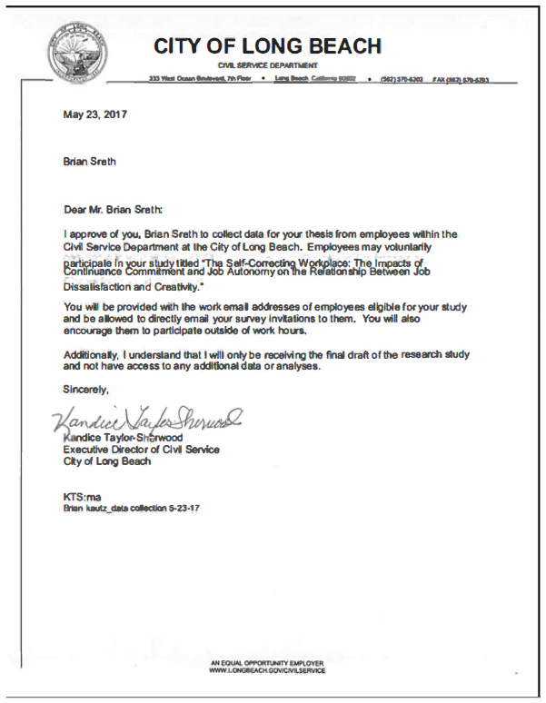

Sample Recruitment Flyer
